PUBLIC NOTICE OF SCHOOL BOARD MEETING

OF MARSHALL PUBLIC SCHOOL DISTRICT

PUBLIC NOTICE is hereby given to the public and news media pursuant to Wisconsin Laws that a SPECIAL MEETING: Committee of the Whole of the School Board of Jt. School District No. 2, Village of Marshall, towns of Cottage Grove, Deerfield, Medina, Sun Prairie, and York, Dane County, Wisconsin will be held on September 12, 2018 commencing at 5:00 PM at the regular meeting place of said School Board in the District Office located in the Marshall Elementary School (617 Madison St.) in the Village of Marshall, Dane County, Wisconsin and that the preliminary agenda for said meeting is as follows:

AGENDA

1. Call to order
- Roll call
- Approval of agenda
- Proof of giving public notice
- Presentation and discussion regarding Studer Education
- Adjournment

These are the items known at this time. Adjustments may be made up to 24 hours prior to board meetings. Changes will be posted at each school site, Post Office, F&M Bank, and Marshall Public Library.

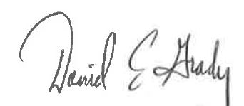
Designee of School Board President

DATED: September 7, 2018

